Visualization Tool for Electric Vehicle Charge and Range Analysis

Project Overview

Introduction:
Electric Vehicles (EVs) are becoming an essential part of modern transportation due to their environmental benefits and energy efficiency. With the increasing adoption of EVs, a large amount of data related to charging stations, battery performance, driving range, vehicle efficiency, and charging behavior is generated every day. Analyzing this data manually is difficult and time-consuming. This project aims to analyze Electric Vehicle charging and range data using SQL, Tableau, and Flask to create interactive dashboards and generate meaningful insights for users, businesses, and city planners.

Problem Statement:
The rapid growth of electric vehicles has led to the generation of massive datasets containing information about charging patterns, battery performance, vehicle range, charging stations, and EV models. Extracting meaningful insights from this data without proper visualization tools is challenging. There is a need for an interactive analytics system that can analyze EV data, compare vehicle performance, identify charging trends, and present the results through user-friendly dashboards.
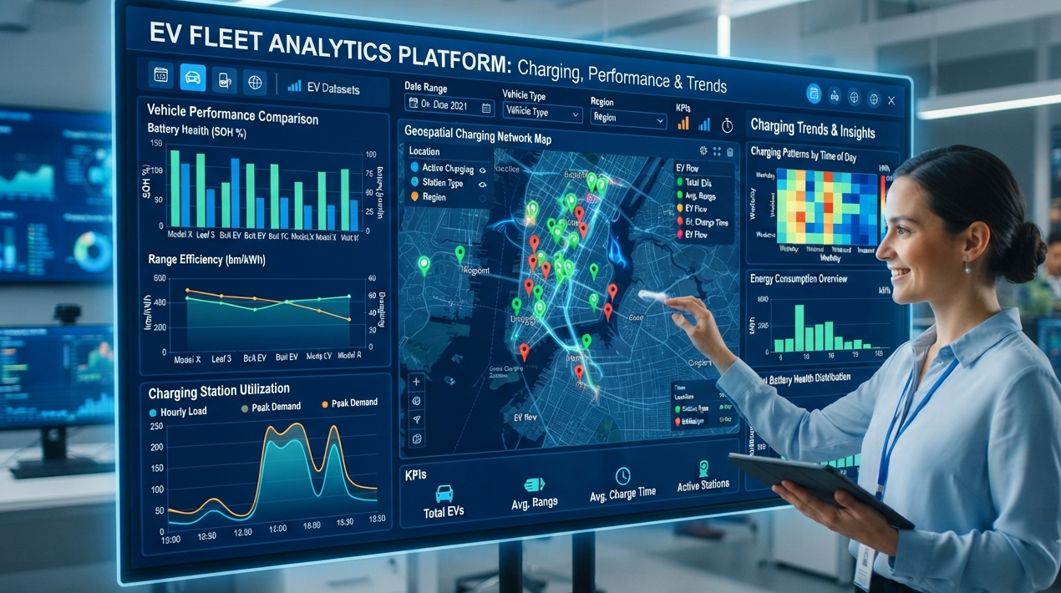

Objectives
- Analyze charging patterns and electricity usage of electric vehicles.
- Study battery performance and its impact on driving range.
- Compare the efficiency of different EV models and brands.
- Visualize EV charging stations across different regions.
- Create interactive dashboards and stories using Tableau.
- Integrate Tableau dashboards into a Flask web application.
- Generate business insights to support decision-making.

Features of the Project
- Database Management
- Data Collection and Storage
- Data Cleaning and Preprocessing
- SQL-Based Data Analysis
- Interactive Tableau Dashboards
- Dynamic Data Filters
- KPI Cards and Performance Metrics
- Maps, Charts, and Graphs
- Story Creation
- Tableau Public Publishing
- Flask Web Integration
- User-Friendly Interface
- Comparative EV Model Analysis
- Battery Performance Analysis
- Charging Pattern Analysis
System Architecture:
CSV Dataset
│
▼
My SQL / Oracle SQL Database
│
▼
SQL Query Analysis
│
▼
Tableau Dashboard & Story
│
▼
Tableau Public
│
▼
Flask Web Application
│
▼
User
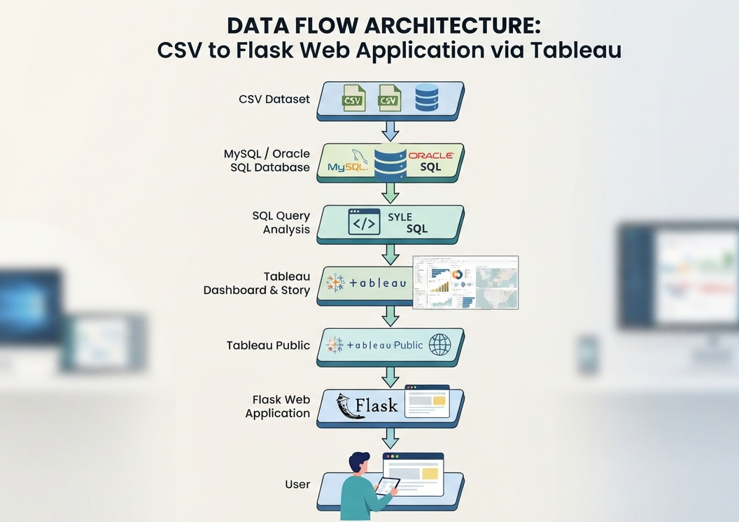

Technologies Used
This project uses several technologies to analyze and visualize Electric Vehicle data.
- My SQL / Oracle SQL is used to store and manage the Electric Vehicle dataset in a structured format.
- SQL is used to perform data analysis, retrieve information, and generate insights from the stored data.
- Tableau is used to create interactive dashboards, charts, maps, and visualizations.
- Tableau Public is used to publish the dashboards online so that they can be easily shared and accessed.
- Python Flask is used to develop the web application and integrate the Tableau dashboards into the website.
- HTML is used to design the structure and content of the web pages.
- CSS is used to improve the appearance of the website by adding styles, layouts, and responsive designs.
Together, these technologies help transform raw Electric Vehicle data into meaningful visual insights through an interactive and user-friendly web application.

Working of the Project

Step 1 – Data Collection
The EV dataset containing charging stations, battery capacity, driving range, vehicle models, charging time, and efficiency is collected from reliable sources.

Step 2 – Database Storage
The collected dataset is imported into My SQL/Oracle SQL Database for structured storage and efficient data management.

Step 3 – SQL Operations
SQL queries such as COUNT (), SUM (), AVG (), GROUP BY, ORDER BY, HAVING, and Window Functions are used to analyze charging behavior, battery efficiency, and vehicle performance.

Step 4 – Tableau Visualization
The database is connected to Tableau to create interactive dashboards including:
- Charging Station Maps
- Battery Performance Charts
- Driving Range Analysis
- EV Brand Comparison
- Charging Pattern Analysis
- KPI Cards
- Interactive Filters

Step 5 – Publishing
The dashboards and stories are published to Tableau Public for online accessibility.

Step 6 – Flask Integration
The published Tableau dashboards are embedded into a Flask web application using HTML I frames, allowing users to interact with the visualizations through a responsive website.

Result
The project successfully analyzes Electric Vehicle charging patterns, battery performance, driving range, and vehicle efficiency using SQL and Tableau. Interactive dashboards provide users with insights into charging infrastructure, EV model comparison, charging duration, battery health, and overall performance. The dashboards are published on Tableau Public and integrated into a Flask web application for easy access and real-time visualization.
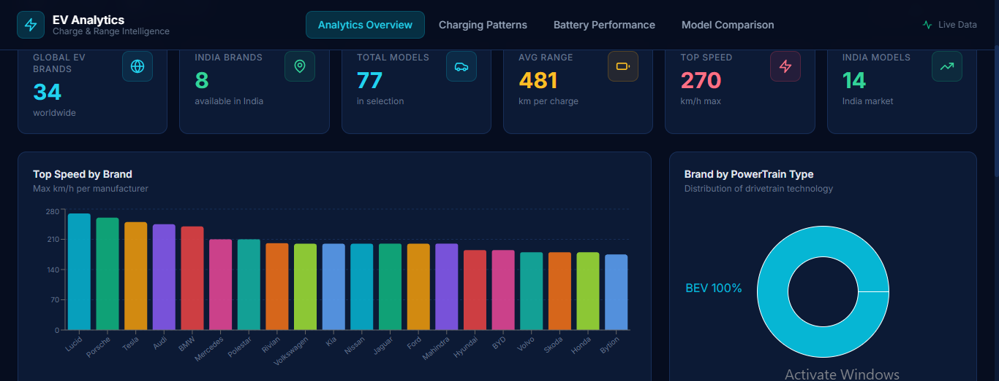
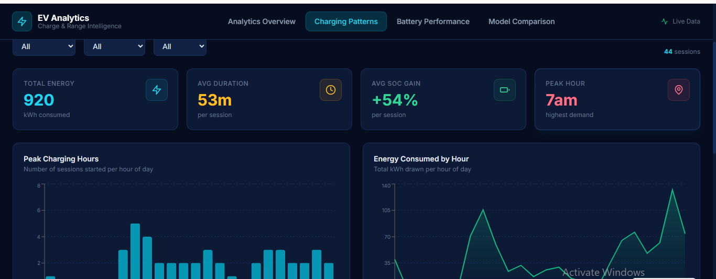
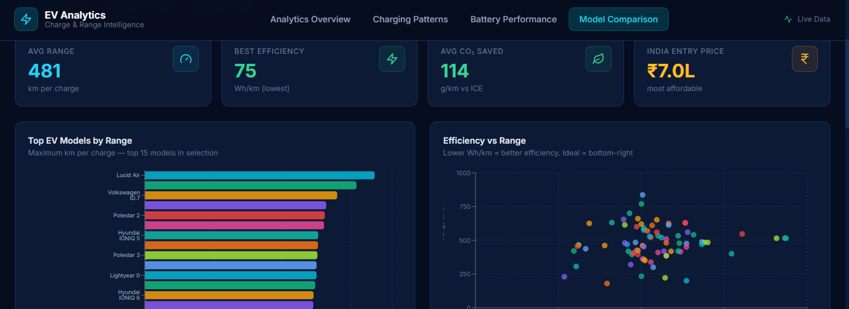

Conclusion
This project demonstrates how SQL, Tableau, and Flask can be combined to transform raw Electric Vehicle data into meaningful visual insights. The developed dashboards help users analyze charging behavior, compare EV models, evaluate battery performance, and understand charging infrastructure trends. The Flask integration provides a simple and interactive web interface, making the project effective, user-friendly, and valuable for EV analytics and decision-making

